Press Release
It also works without:
STARgate HRS revolutionizes hot runner technology
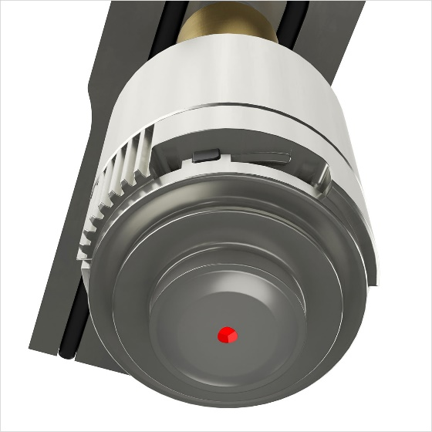 | 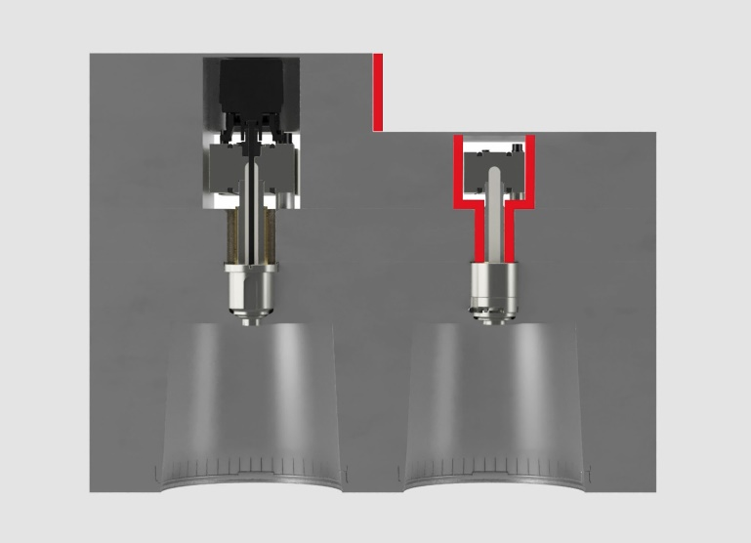
Oerlikon HRSflow's new STARgate HRS® hot runner technology uses a diaphragm-like element in the gate plane to manage melt flow into the cavity.  © Oerlikon HRSflow | left: the standard valve gate solution; right: the STARgate HRS® technology, which reduces cycle time and requires significantly less installation space than conventional needle valve systems.  © Oerlikon HRSflow

San Polo di Piave/Italy, October 2025 – At K 2025 in Hall 1/Booth C72, Oerlikon HRSflow will unveal its patented STARgate HRS® hot runner technology, featuring a completely redesigned gate unit. Unlike conventional designs with axially moving needles, this revolutionary technology uses a diaphragm-like element in the gate plane to manage melt flow into the cavity. Eliminating the need for needles provides numerous processing and cost advantages.
Thanks to its diaphragmatic concept delivering optimal cooling performance, STARgate HRS offers a significant reduction in cycle time as a key advantage, resulting in higher productivity. The absence of components required for guiding and moving the needle also streamlines manufacturing, assembly, and maintenance operations. Its innovative design eliminates the need for actuator installation space, which is typically positioned axially above the needles in conventional systems, allowing for thinner back plates. Additionally, the innovative pinless configuration allows for smaller nozzle diameters and reduced mold pocket sizes, making the STARgate HRS an exceptionally compact solution.
The combination of smooth plastic flow and a reduced stagnation area enables faster color changes, lower scrap quantities, and lower pressure losses. Additionally, the easily replaceable gate insert reduces maintenance costs. The external position of the actuator contributes to lower energy consumption because it does not require cooling.
Experience at the Oerlikon HRSflow R&D Technical Center shows that the new STARgate HRS technology is ideal for injection molding medium-to-large parts with reduced holding and cycle times. For these types of applications, the cycle time can be up to 20% shorter than with conventional gate systems.
Massimo Rossi, R&D Director at Oerlikon HRSflow, comments: “A new era in valve gate solutions has begun. The needle-free STARgate HRS hot runner technology, which is expected to be available by mid-2026, is a true game changer, because it will radically transform the processing of amorphous thermoplastics. Ongoing developments aim to expand its range of applications. We are proud of this achievement by our development team, which includes employees from across the company.”
STARgate HRS will be demonstrated live at K 2025 in the production of a 6-litre bucket with a 1.1 mm wall thickness at the Italian injection molding machine manufacturer BMB (Hall 13/Booth A33). Project partners include the Dutch plastics processor Dijkstra Plastics, R&D Plastics, Oerlikon Balzers and Piovan.
For further information, please contact:
Chiara Montagner  Marketing & Communication Manager  Oerlikon HRSflow  Tel: +39 0422 750 127  chiara.montagner@oerlikon.com  www.oerlikon.com/hrsflow | Erica Gaggiato  Marketing & Communication Specialist  Oerlikon HRSflow  Tel: +39 0422 750 120  erica.gaggiato@oerlikon.com  www.oerlikon.com/hrsflow
Editorial contact and please send voucher copies to:
Dr.-Ing. Jörg Wolters
Konsens PR GmbH & Co. KG
Hans-Böckler-Str. 20, D-63811 Stockstadt, Germany
Tel: +49 6027 99005 13
mail@konsens.de www.konsens.de
Please find text and image for download at https://www.konsens.de/hrsflow

